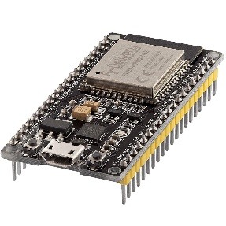 | COMPUTER SCIENCE DEPARTMENT  TC1004B – INTERNET OF THINGS IMPLEMENTATION  HOMEWORK 2 – Threads
 | Name: _________________________  ID: _________________________ | Name: _________________________  ID: _________________________

Instructions:

Section 1: Vector addition with threads

- Write a program that adds two vectors. Receive the dimension N from the command line. Launch a thread that calculates each element of the resulting vector. Test with N = 10

- Fill out the following:

Listing 1.1. Commented code

Short description (no more than 10 lines) of the implemented algorithm on a yellow square.

Listing 1.2. System/Program description

Listing 1.3. Screenshot/picture of the working system/program

